EXPERIMENT 06

Aim
To design an interactive Executive Dashboard and Business Scorecard in Microsoft Power BI for monitoring organizational performance, supporting business decisions, and communicating key performance indicators.

Objectives
- Identify business metrics for executive performance monitoring.
- Create KPI cards for Total Sales, Total Profit, Total Orders, and Profit Margin.
- Visualize regional, category, monthly, customer, and segment performance.
- Add slicers and verify that report visuals respond to selections.
- Compare actual performance with targets using a business scorecard.
- Analyze the results and prepare a data-driven recommendation.

Tools and dataset
- Microsoft Power BI Desktop and its built-in Power Query Editor.
- Global Superstore Dataset.xlsx.
- DAX (Data Analysis Expressions) for calculated measures.
Dataset source: https://www.kaggle.com/datasets/apoorvaappz/global-super-store-dataset

Initial workflow
A1 | Open Power BI Desktop
Open the project created in earlier experiments if available. If it is not available, start a new report.
A2 | Load the workbook if required
Choose Home > Get data > Excel workbook. Browse to Global Superstore Dataset.xlsx, select the required worksheet or table, and click Load. If the dataset is already loaded, verify it in the Fields/Data pane.
A3 | Verify analysis fields
Check that Sales, Profit, Order ID, Customer Name, Category, Segment, Region, Order Date, and Year are available.
A4 | Plan the page arrangement
Reserve the upper area for KPI cards, the main section for charts, and a side or top area for slicers. Keep a clear space for the scorecard and use consistent titles and number formats.
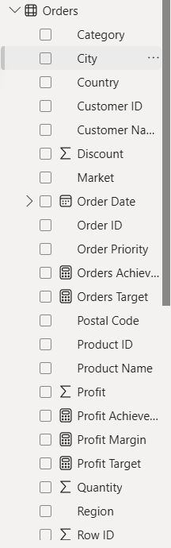
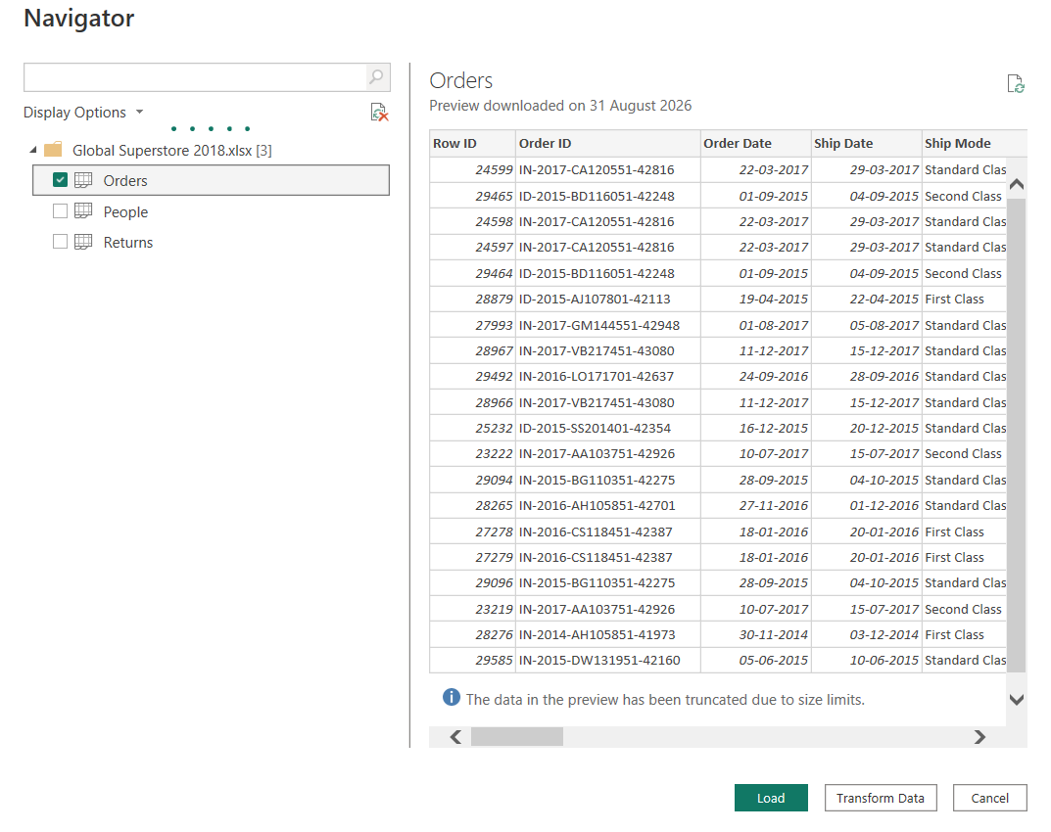

02 / KPI CONSTRUCTION

Calculate the Main Performance Indicators
Create the DAX measures first. These calculations will supply the values displayed in the KPI cards and used in the dashboard.

Create the DAX measures
B1 | Total Sales
Select the table containing the sales records, choose Modeling > New measure, and enter: Total Sales = SUM(Orders[Sales]). Replace Orders with the actual table name if it differs.
B2 | Total Profit
Create another measure: Total Profit = SUM(Orders[Profit]). Use the actual table name in your model.
B3 | Total Orders
Enter: Total Orders = DISTINCTCOUNT(Orders[Order ID]). This counts unique orders rather than counting every row.
B4 | Profit Margin
Enter: Profit Margin = DIVIDE([Total Profit], [Total Sales], 0). Select the measure and format it as Percentage from the Measure tools or Modeling ribbon.

Measures reference
Total Sales = SUM(Orders[Sales])
Total Profit = SUM(Orders[Profit])
Total Orders = DISTINCTCOUNT(Orders[Order ID])
Profit Margin = DIVIDE([Total Profit], [Total Sales], 0)

Present the KPIs
B5 | Insert four Card visuals
In Report view, add four Card visuals and assign one measure to each: Total Sales, Total Profit, Total Orders, and Profit Margin.
B6 | Format the cards
Add descriptive titles, choose suitable number formats, and align the cards consistently. Ensure Profit Margin is displayed as a percentage.
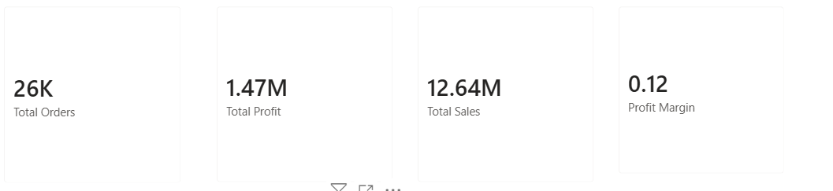

03 / PERFORMANCE VISUALS

Compare Results Across Business Dimensions
Use charts to highlight where sales and profit are generated and how customer and monthly performance changes.
C1 | Sales by Region
Add a bar or column chart. Place Region on the Axis and Total Sales (or Sales) in Values. Give it a clear title.
C2 | Sales by Category
Create a second chart with Category on the Axis and Sales in Values.
C3 | Monthly Sales Trend
Insert a line chart. Place Order Date on the X-axis and Sales or Total Sales in Values. Use the date hierarchy or a Month-Year field, and sort the timeline chronologically.
C4 | Top 10 Customers by Sales
Add a bar chart with Customer Name on the Axis and Sales in Values. In the Filters pane, change Customer Name to Top N, enter 10, use Sales as the By value field, and apply the filter. Sort sales in descending order.
C5 | Profit by Segment
Insert a bar or column chart with Segment on the Axis and Profit in Values.
C6 | Format and arrange the charts
Apply readable labels, consistent number formats, clear titles, and a uniform visual style. Position the visuals neatly without overcrowding the report.
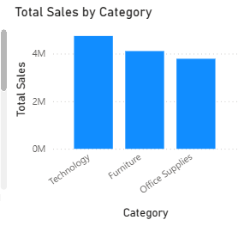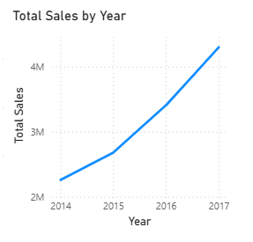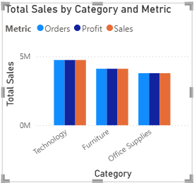

04 / INTERACTIVE CONTROLS

Add Slicers and Validate Dashboard Behaviour
Slicers let an executive focus on selected parts of the business while keeping the report interactive.
D1 | Add the Region slicer
Insert a Slicer visual and add Region. Choose list or dropdown style according to the space available.
D2 | Add Category and Year slicers
Insert two more slicers. Add Category to one and Year, or the year level of Order Date, to the other. Label each control clearly.
D3 | Check visual interactions
Select a slicer and open Format > Edit interactions if required. Confirm that the relevant charts and KPI cards respond to Region, Category, and Year selections.
D4 | Test different selections
Change the slicers individually and in combinations. Check that values update, labels remain readable, and no chart is clipped.
D5 | Restore the overall view
Clear the slicer selections and verify that the report returns to its unfiltered state.
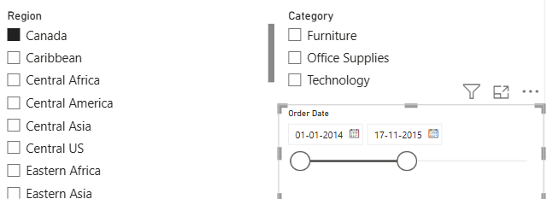
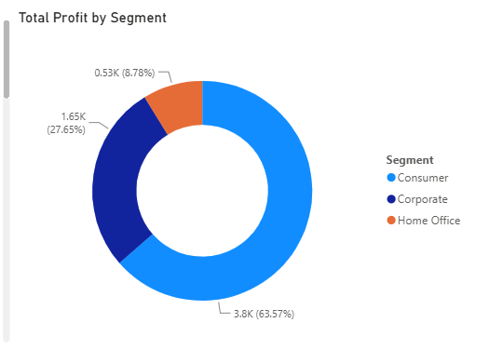

05 / TARGET TRACKING

Develop the Business Scorecard
A scorecard compares actual results with predefined targets. Targets must come from the lab instructions or be stated clearly as business assumptions.
E1 | Decide the target values
Set targets for Sales, Profit, and Orders using the lab instructions or a clearly documented business assumption. Do not present assumed targets as historical actual values.
E2 | Create target measures
Use Modeling > New measure to define target measures for Sales, Profit, and Orders using the selected target values.
E3 | Calculate achievement percentages
Create a measure for each achievement percentage by dividing the actual value by its corresponding target. Example: Sales Achievement % = DIVIDE([Total Sales], [Sales Target], 0). Repeat for Profit and Orders.
E4 | Build the scorecard visual
Insert a Table or Matrix visual. Include Sales, Profit, and Orders, and show the actual value, target value, and achievement percentage for each.
E5 | Apply conditional formatting
Format achievement percentages or status fields. Unless the instructor specifies different limits, use Achieved for 100% or more, Partially Achieved for 80% to below 100%, and Not Achieved for below 80%. Use colors or icons consistently.
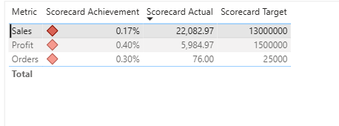

Achievement status guide
Status | Achievement rule | Interpretation
Achieved | 100% or more | Target met or exceeded.
Partially Achieved | 80% to below 100% | Performance is approaching the target.
Not Achieved | Below 80% | Performance is below the selected threshold.

06 / FINDINGS AND SUBMISSION

Interpret the Results and Finalize the Report
Use the values displayed in the completed dashboard and scorecard. Enter observed findings rather than assumed conclusions.
F1 | Evaluate regional performance
Compare Sales and Profit across regions. Record the strongest and weakest region and state whether the comparison is based on Sales, Profit, or both.
F2 | Evaluate category profitability
Compare Profit by Category. Identify the category with the highest profit and the category with the lowest profit using the chart.
F3 | Write a business recommendation
Prepare one practical recommendation supported by the findings. For example, investigate low-profit regions or categories by reviewing costs and product mix, and consider practices used in stronger-performing areas.
F4 | Save the Power BI file
Choose File > Save As and use a clear name such as Executive_Dashboard_Scorecard.pbix. Review the dashboard and scorecard before submission.
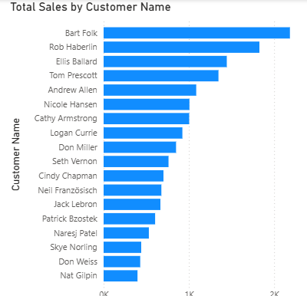

Result
An Executive Dashboard and Business Scorecard were developed in Microsoft Power BI using the Global Superstore dataset. KPI cards, charts, slicers, and a scorecard were used to monitor business performance and support analysis. The findings were reviewed to identify performance differences and formulate a business recommendation.

Learning outcomes
- Designed interactive dashboards using Power BI visualizations (CO5–BT6).
- Created KPI-based scorecards for performance monitoring (CO5–BT6).
- Applied visualization practices in dashboard design (CO3–BT3).

